**Program Description:** The program is designed to manage and output course information for a university system. It reads course data from CoursesFall2023Tab.txt, processes it into structured objects, and then writes formatted course details to an output file(output.txt).

**Sample Output:**

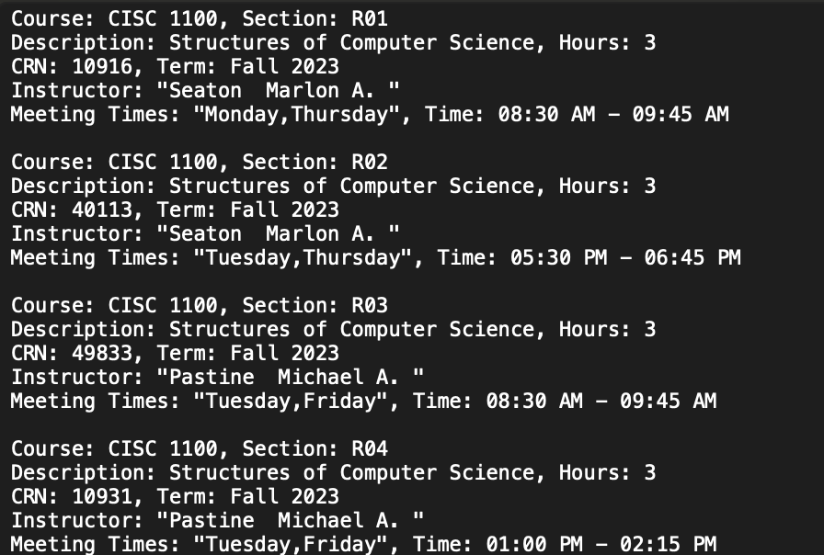

Features Demonstrated:

1. Overloading (Any, including: +, << or >>). +1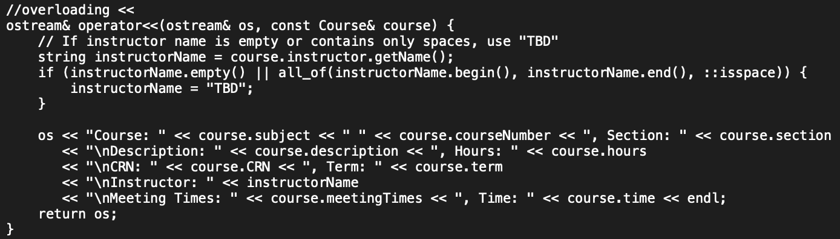
2. I/O parsing a new file for new class with new functionality. +1

Reads from CoursesFall2023Tab.txt and output to an output.txt file.

1. New object related to current UM & Student with accessors and mutators. +1

The Course class is a new object type related to UnivMember and contains extensive accessors and mutators for its properties.

1. Save output to a file. +1
2. Upload to Git Hub. +1
3. Show all information() about a course. +1

Course: [Subject] [Number], Section: [Section]

Description: [Description], Hours: [Hours]

CRN: [CRN], Term: [Term]

Instructor: [Instructor Name]

Meeting Times: [Meeting Times], Time: [Time]